Northern Lights Nordic Ski Club
November 2014

Northern Lights Nordic Ski Club is a 501c-3 non-profit organization dedicated to promoting cross-country skiing as a healthful, family activity. Our membership has grown since 1991 and presently includes over two hundred fifty families. Club members volunteer their time to groom and maintain eight area ski trails and work with the Grand Rapids, Deer River and Remer High School ski teams, Minnesota Youth Ski League, Mount Itasca Nordic Ski Association, Itasca County Trails Task Force and other local and statewide organizations. Our funding comes from member donations, state grant-in-aid, and fund raising events. We strive to continually improve Nordic skiing in our area for all ages and abilities.
Board of Directors
Pete Friedlieb, President Jim Christmas, Suomi Hills liaison Greg (Boomer) Moritko Director of grooming Bob Conzemius, Vice-president Craig Stertz, Director of ski clinics Rick McDonald, Director of Legion Trail Tom Sobolik, Treasurer Paul Olson, Director of GPS mapping Catherine McLynn, Newsletter/Membership Alan and Amy Dettmer Mt Itasca liaisons Randy Zupan Suomi groomer Cathleen Bengtson, Secretary
Trailbits November 2014
Pete Friedlieb

Your board decided that some poetry might be a good idea. After all this was now a regular feature on KAXE where we were meeting. So here goes:

No sun-no moon!
No morn-no noon-
No dawn-no dusk-no proper time of day.
No warmth, no cheerfulness, no healthful ease,
No comfortable feel in any member-
No shade, no shine, no leaves, no bees-
No fruits, no flowers, no leaves, no birds!-
November! Thomas Hood

On that not so happy note your board decided maybe we would forego poetry and get down to bidness:

Swap-December 2, Tuesday at Itasca Trail Sports from 4 to 7 pm. Bring or buy used cross country ski equipment beginning at 10 am when the shop opens. Club members should plan to come and help with the lively exchange of equipment and conversation.

Website-Check out our new website thanks to Keith Murphy! And boy is it cool! www.NorthernLightsNordic.org will link you to trail reports, pictures, and more!

Membership-Time to renew your membership/donation. Please do it today! With your support we’ve been able to continually improve grooming and trail work since we started 20 years ago. Send check and form below to NLNSC, 931 N Pokegama Ave. GR. 55744

Equipment-We purchased a new trailer with Club funds and a 49% grant from Trails Task Force. Our old one was worn out and dangerous. Also we sold the Tucker Sno Cat that was at Blueberry Hills. Smaller lighter equipment is better for that trail. Over the next 6 months or so we’ll look ongoing annual upgrades of our equipment much of which averages over 10 years old with the exception of the new Gator.

Robin Baker Memorial Bench-Hand-crafted by Randy Zupan. This will be placed at Blueberry with a dedication ceremony planned for the near future. Robin is also being inducted into the Nordic Ski Coaching Hall of Fame.
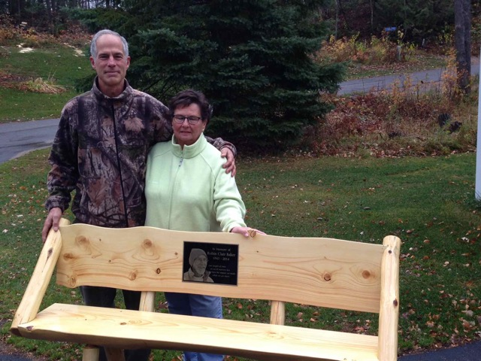

Randy with Brenda Baker

Trail Report-All trails have been cleared more than once and have at least a few inches of snow. Mount Itasca already has piles of snow thanks to volunteers’ working day and night during this week’s cold snap. Stay tuned for early grooming reports!

There was more but there’s the highlights! Your board finished its work and trudged out looking for December.

Remember to get your Great Minnesota Ski Pass and renew your tax deductible NLNSC membership. Send check to address below. Invite a friend to join!
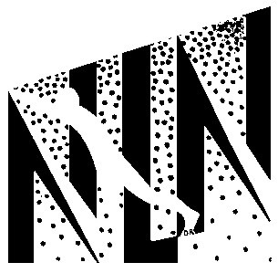NORTHERN LIGHTS NORDIC SKI CLUB
Name ____________________________________________________________________________________
Address __________________________________________________________________________________

Telephone _______________________________ e-mail ___________________________________________

Membership fee enclosed: Benefactor $100.00______ Sustaining $50.00_______
Family $25.00 _______ Individual $15.00_______ Student $5.00_______
We need your membership to promote, maintain and improve Nordic skiing as a lifetime sport.
Mail to: NLNSC • 931 North Pokegama Ave, Grand Rapids, MN 55744 Need more information? Call 218-326-1313.

